About Science
Conceptual Physic Instructor’s Manual, 12th Edition, Global Edition

1.1 Scientific Measurements
How Eratosthenes Measured the Size of Earth
Size of the Moon
Distance to the Moon
Distance to the Sun
Size of the Sun
Mathematics—The Language of Science
1.2 Scientific Methods
The Scientific Attitude
1.3 Science, Art, and Religion
Pseudoscience
1.4 Science and Technology
Risk Assessment
1.5 Physics—The Basic Science
1.6 In Perspective

Much of this introductory chapter, like most introductions, can be regarded as a personal essay by the author. While many physics instructors may discuss somewhat different topics in a somewhat different way, the comments made here may prove to be useful as a background for further comments of your own.

The chapter opens with a pair of photos of my wife beneath a tree in front of our residence in San Francisco. They replace the rendered photos of a partial eclipse of the previous edition. This pair of photos is real, and others taken by Dean Baird and Paul Doherty are in Chapter 26. The pair of photos lead to the profile of Eratosthenes, and his early measurements of the Earth. Such merits further explanation and a good way to kick off your course. Follow this up with the early measurement of the Moon and Sun by Aristarchus. More on these early measurements is found in the excellent book Physics for the Inquiring Mind, by Eric Rogers, originally published in 1960 by Princeton University Press.

You may consider elaborating on the idea about the possible wrongness versus rightness of ideas; an idea that characterizes science. This is generally misunderstood, for it is not generally a criterion in other disciplines. State that it is the prerogative of science, in contrast to the speculative procedures of philosophy and meta-physics, to embrace only ideas that can be tested and to disregard the rest. Ideas that can’t be tested are not necessarily wrong—they are simply useless insofar as advancement in scientific knowledge is concerned. Ideas must be verifiable by other scientists. In this way science tends to be self-correcting.

Expand on the idea that honesty in science is not only a matter of public interest, but is a matter of self-interest. Any scientist who misrepresents or fudges data, or is caught lying about scientific information, is ostracized by the scientific community. There are no second chances. The high standards for acceptable performance in science, unfortunately, do not extend to other fields that are as important to the human condition. For example, consider the standards of performance required of politicians.

Distinguish between hypothesis, theory, fact, and concept. Point out that theory and hypothesis are not the same. A theory applies to a synthesis of a large body of information. The criterion of a theory is not whether it is true or untrue, but rather whether it is useful or nonuseful. A theory is useful even though the ultimate causes of the phenomena it encompasses are unknown. For example, we accept the theory of gravitation as a useful synthesis of available knowledge that relates to the mutual attraction of bodies. The theory can be refined, or with new information it can take on a new direction. It is important to acknowledge the common misunderstanding of what a scientific theory is, as revealed by those who say, “But it is not a fact; it is only a theory.” Many people have the mistaken notion that a theory is tentative or speculative, while a fact is absolute.

Impress upon your class that a fact is not immutable and absolute, but is generally a close agreement by competent observers of a series of observations of the same phenomena. The observations must be testable. Since the activity of science is the determination of the most probable, there are no absolutes. Facts that were held to be absolute in the past are seen altogether differently in the light of present-day knowledge.

By concept, we mean the intellectual framework that is part of a theory. We speak of the concept of time, the concept of energy, or the concept of a force field. Time is related to motion in space and is the substance of the Theory of Special Relativity. We find that energy exists in tiny grains, or quanta, which is a central concept in the Quantum Theory. An important concept in Newton’s Theory of Universal Gravitation is the idea of a force field that surrounds a material body. A concept envelops the overriding idea that underlies various phenomena. Thus, when we think “conceptually” we envelop a generalized way of looking at things.

Prediction in science is different than prediction in other areas. In the everyday sense, one speaks of predicting what has not yet occurred, like whether or not it will rain next weekend. In science, however, prediction is not so much about what will happen, but about what is happening and is not yet noticed, like what the properties of a hypothetical particle are and are not. A scientist predicts what can and cannot happen, rather than what will or will not happen.

In biology, for example, you explain events once you see them. In a sense you’re looking at the historical behavior and then you explain patterns. In physics you’re more likely to predict patterns before they’re seen.

Max Born, Nobel-prize recipient and one of the most outstanding physicists of the twentieth century, is quoted in the insight box of page 38. It was to a letter to Max by his close friend Albert Einstein in 1926 that Einstein made his famous remark regarding quantum mechanics, often paraphrased as “God does not play dice with the universe.” Max Born died in 1970, and was the maternal grandfather of the popular singer Olivia Newton-John.

Science and Technology
In discussions of science and technology and their side effects, a useful statement is: You can never do just one thing. This is similar to “there is never just one force” in discussions of Newton’s third law.

With regard to risk, you can prove something to be unsafe, but you can never prove something to be completely safe.

Engineering is the practical application of science to commerce or industry. The tripartite arrangement of science, technology, and engineering has always been the combination for successful advancement.

“Any sufficiently advanced society is indistinguishable from magic.” Arthur C. Clark

One can quip that a first stage of scientific discovery is to deny that it’s true, the second is to deny that it’s important, and the third is to credit the wrong person.

The medieval philosopher, William of Occam, wisely stated that when deciding between two competing theories, choose the simpler explanation—don’t make more assumptions than are necessary when describing phenomena.

Physicists have a deep-seated need to know “Why?” and “What if?”. Mathematics is foremost in the toolkits they develop to tackle these questions. Galileo stated that the book of nature is written in mathematics. (Tidbit: Galileo and Shakespeare were born in the same year, 1564.)

Science is never a closed book, for its conclusions are based on evidence, and new evidence can contradict old conclusions and lead to a better understanding of nature. Anytime anybody tells you that they are “absolutely certain” of some general idea, you can be assured that their conclusion is not scientific, because science never produces absolute certainty. - Art Hobson
Science and Religion
Do the two contradict each other—must one choose between them? These questions are foremost among many students, yet physics texts usually sidestep such questions, for religion is very personal for so many people. I hope the very brief treatment in the text presents a satisfactory answer to these questions. Your feedback on this matter will be appreciated.

With regard to science courses and liberal arts courses, there is a central factor that makes it difficult for liberal arts students to delve into science courses the way that science students can delve into liberal arts courses—and that’s the vertical nature of science courses. They build upon each other, as noted by their prerequisites. A science student can take an intermediate course in literature, poetry, or history at any time, and in any order. But in no way can a humanities student take an intermediate physics or chemistry course without first having a foundation in elementary physics and mathematics. Hence the importance of this conceptual course.

Except of the measurements by early Greek scientists, I do not lecture about Chapter 1 material and instead assign it as reading. It can be omitted without interfering with the following chapters.

Measuring Solar Diameter: One of my very favorite class assignments is the task of measuring the diameter of the Sun with a ruler or tape measure. This makes sense by first explaining the physics of a pinhole camera. The pinhole image technique is described on Practice Page 33. Hold a meterstick up and state to the class that with such a measuring device, a strip of measuring tape or a simple ruler, they can measure the diameter of the Sun. Call attention to Figure 1.6, then sketch a simple pinhole camera on the board thusly.
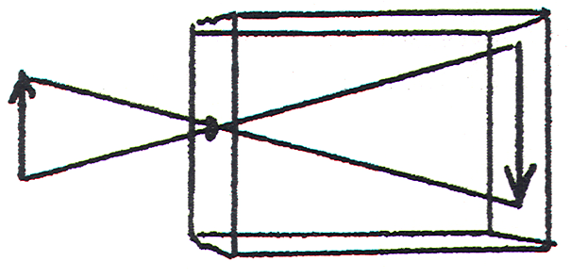
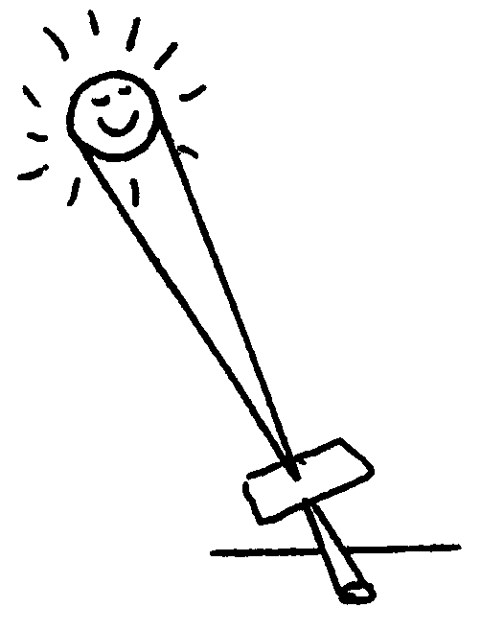
Tell of how a small hole poked in a piece of cardboard will show the image of the Sun when the card is placed in sunlight. You can explain this without referring to Figure 1.6 in the text because the figure gives the ratio you wish them to determine. I find this first assignment very successful, in that simple measurements yield a most impressive value—a confidence builder. For those who don’t succeed, or succeed partially, I urge them to try again for full credit.

Practicing Physics Book:
• Making Hypotheses
• Pinhole Formation

Next-Time Questions (in the Instructor’s Resource Material):
• Scientific Claims
• Pinhole Image of the Sun
• Solar Image
• Cone, Ball, and a Cup

Laboratory Manual:
There are no labs for Chapter 1
Answers for Chapter 1

Reading Check Questions
1. Science is the product of human curiosity about how the world works—an organized body of knowledge that describes order and causes within nature and an ongoing human activity dedicated to gathering and organizing knowledge about the world.
2. The general reaction has been to forbid new ideas.
3. Alexandria was farther north, at a higher latitude.
4. This is due to the huge size difference between the Sun, the Moon, and Earth; and also due to the tilt of the Moon’s orbit with respect to the plane of Earth’s orbit around the Sun.
5. Like the Sun, the Moon’s diameter is 1/110 the distance between Earth and the Moon.
6. The Sun’s diameter is 1/110 the distance between Earth and the Sun.
7. At the time of a half moon he knew the angle between a line joining the Moon and Earth was at 90° to the line joining the Moon and the Sun.
8. The circular spots are pinhole images of the Sun.
9. The equations are guides to thinking that show the connections between concepts in nature.
10. The modern scientist first examines the way the world actually works and then builds a structure to explain the findings.
11. The answer is as stated in the Summary of Terms.
12. Competent scientists must be experts at changing their minds.
13. A scientific hypothesis becomes a law when it has been tested over and over again and has not been contradicted.
14. Whereas mistakes or misrepresentations are given second chances in daily life, second chances are not given to scientists by the scientific community.
15. See if you can state the position of an antagonist to the antagonist’s satisfaction, and compare it to how well the antagonist can state your position. If you can, and your antagonist can’t, the likelihood is that you are correct in your position.
16. To know more than what’s in your bag of beliefs and attitudes is to expand your education.
17. No. Science and religion can work well together, and even complement each other. (Religious extremists, however, may assert that the two are incompatible).
18. One benefit is an open and exploring mind.
19. Science is gathering knowledge and organizing it; technology puts scientific knowledge to practical use and provides the instruments scientists need to conduct their investigations.
20. The concepts of physics are the base for the more complex concepts and structures which are the subjects of inquiry in chemistry and biology.

Think and Do
21. The triangle coin image-coin distance is similar to the larger triangle Sun diameter-Sun distance, so the numbers of coins and Suns are the same. The number of Suns that would fit between Earth’s surface and the Sun is 110.

22. Open ended, as lists will vary.

Think and Explain
23. Atomic theory has undergone change over time.

24. (a) This is a scientific hypothesis, for there is a test for wrongness. For example, you can extract chlorophyll from grass and note its color.
(b) This statement is without a means of proving it wrong and is not a scientific hypothesis. It is speculation.
(c) This is a scientific hypothesis. It could be proved wrong, for example, by showing tides that do not correspond to the position of the Moon.

25. Aristotle’s hypotheses was partially correct. Plant material comes partly from the soil, but mainly from the air and water. An experiment would be to weigh a pot of soil with a small seedling, then weigh the potted plant later after it has grown. The fact that the grown plant will weigh more is evidence that the plant is composed of more material than the soil offers. Keep a record of the weight of water used to water the plant, and cover the soil with plastic wrap to minimize evaporation losses. Then the weight of the grown plant can be compared with the weight of water it absorbs. How can the weight of air taken in by the plant be estimated?

26. The Sun’s radius is approximately 7 × 10⁸ m. The distance between the Earth and Moon is about 4 × 10⁸ m. So the Sun’s radius is much larger, nearly twice the distance between the Earth and Moon. The Earth and Moon at their present distance from each other would easily fit inside the Sun. The Sun is really big—surprisingly big!

27. No, experimental validation is necessary for a hypothesis to be considered scientific.
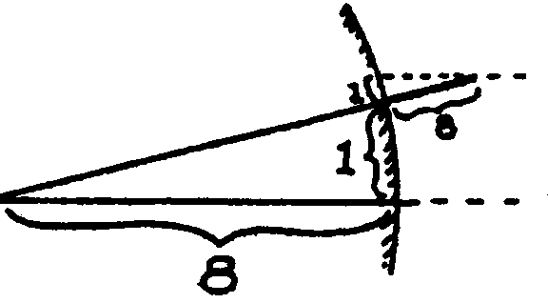
28. Yes, there is a geometric connection between the two ratios.
As the sketch shows, they are approximately equal.

$\frac{\text{Pole shadow}}{\text{Pole height}}\text{ = }\frac{\text{Alexandria-Syene distance}}{\text{Earth radius}}$

From this pair of ratios, given the distance between
Alexandria and Syene, the radius of the Earth can be calculated!

29. The shadow would be longer because on the smaller planet the angle of the pole would be greater relative to the sunlight. The ratio of the shadow to pole height would be greater than 1 to 8 as in the previous answer.

Think and Discuss
- To publicly change your mind about your ideas is a sign of strength rather than a sign of weakness. It takes more courage to change your ideas when confronted with counter evidence than to hold fast to your ideas. If a person’s ideas and view of the world are no different after a lifetime of varied experience, then that person was either miraculously blessed with unusual wisdom at an early age, or learned nothing. The latter is more likely. Education is learning that which you don’t yet know about. It would be arrogant to think you know it all in the later stages of your education, and stupid to think so at the beginning of your education.

- The examples are endless. Knowledge of electricity, for example, has proven to be extremely useful. The number of people who have been harmed by electricity who understood it is far fewer than the number of people who are harmed by it who don’t understand it. A fear of electricity is much more harmful than useful to one’s general health and attitude.

- Your advice will depend on your own views about questioning authority. Would you suggest that your young congregate with a smaller number of friends who have reasonable doubts than ones who are absolutely certain about everything? If the concern is for the largest numbers of potential friends, groups in the United States that feature non-questioning of authority have enormously large memberships.

